COAN U203Z060M1

Italian  Keywords |  |  | English  Keywords
completo intimo donna |  |  | luxury lingerie
Corsetteria italiana |  |  | luxury lingerie brands
lingerie online |  |  | italian lingerie
maglieria italiana online |  |  | brief
Lana Seta |  |  | slip
pigiami |  |  | bikini online
sottovesti |  |  | sleepwear
reggiseno pizzo |  |  | nightwear
lingerie pizzo |  |  | Knitwear
camicia da notte |  |  | Wool and Silk
biancheria intima |  |  | Italian knitwear
costumi da bagno |  |  | intimate apparel
 |  |  | made in italy
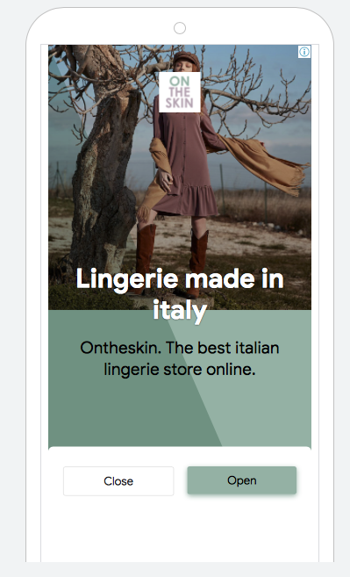
Banner Beispiel B2C

