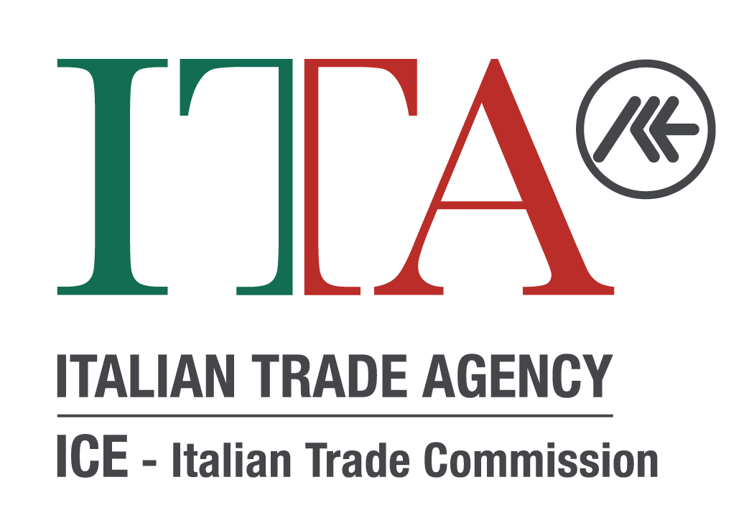

MARKET SURVEY NOTICE

Selection of economic operators to be invited to bidding procedures for amounts below the European community threshold (Euro 214,000.00), to be carried out pursuant to:

- art. 36, paragraph 2, letter a) of Legislative Decree 50/2016, and subsequent amendments and additions;
- articles 7, paragraph 2, letter a) of Ministerial Decree no. 192 of 21 November 2017;

For the following services:

- 2020 Express document shipment overseas;
- 2020 Burglar alarm equipment, access control system, intercom system maintenance burglar and fire alarm central station and radio monitoring services;
- 2020 Elevator maintenance services and test inspections required by the Department of Building’;
- 2020 Plants maintenance services;
- 2020 Annual maintenance agreement for HVAC Equipment;
- 2020 Waste service and recycling;
- 2020 Annual pest control service;
- 2020 Oil burner and Heating oil purchase;
- 2020 Maintenance of Fire alarm system;
- 2020 Maintenance of Fire sprinklers system;
- 2020 Handyman services

Pursuant to art. 36, paragraph 2, letter a) of Legislative Decree 50/2016 and subsequent amendments and additions, art. 7, paragraph 2, letter a) of Ministerial Decree no. 192 of 21 November 2017 in conjunction with Guidelines no. 4, issued by the ANAC in implementation of Legislative Decree 18 April 2016, no. 50, containing "Procedures for the awarding of public contracts for amounts below the thresholds of Community relevance, market surveys and training and management of lists of economic operators" (Resolution No. 1097 of 26 October 2016), and as regards Legislative Decree 19 April 2017, no. 56, it is announced that the ITA New York intends to initiate a negotiated procedure for the acquisition of the service in question, proceeding with the preliminary identification of economic operators – located in the United States and operating services in New York City area - interested in participating in the procedure that are in possession of the general requirements and professional competence, as per articles 80 and 83 of Legislative Decree 50/2016.

CONTENT OF THE REQUESTED SERVICES:

See the above services from no. 1 to no. 10.

DURATION OF SERVICES

The duration of the agreement is 1 (one) year starting from January 1st, 2020 once the contract has been signed and the participation requirements have been verified.

PRESENTATION OF APPLICATIONS FOR PARTICIPATION

This notice will remain published on the website of this office (contracting authority) for a period of 15 days starting from the day following the date of publication.

BUDGET

There is a tentative maximum budget allocated for each of these 2020 Services - please see below. Please note that budget is subject to variations and final approval by ITA’s Headquarters in Rome.

ITA reserves the right to increase or decrease the contractual amount by 20% max as needed, without any further obligation toward the awarded Contractor.

Requests for participation by economic operators interested in the selection procedure in question must be signed by the legal representative of the company, or his delegate, and sent to the e-mail address newyork@ice.it no later than 12:00 noon on December 10th, 2019 clearly indicating in the subject of email one of the following each statement (estimate budget):

2020 Express document shipment overseas; ($4,200.00)
2020 Burglar alarm equipment, access control system, intercom system maintenance burglar and fire alarm central station and radio monitoring services; ($8,000.00)
2020 Elevator maintenance services and test inspections required by the Department of Building’; ($8,000.00)
2020 Plants maintenance services; ($4,000.00)
2020 Annual maintenance agreement for HVAC Equipment; ($15,000.00)
2020 Waste service and recycling; ($6,000.00)
2020 Annual pest control service; ($3,000.00)
2020 Oil burner and Heating oil purchase; ($20,000.00)
2020 Maintenance of Fire alarm system; ($6,000.00)
2020 Maintenance of Fire sprinklers system ($10,000.00)
2020 Handyman Services ($ 15,000.00)

And must include the following attachments:

- Enclosed application form “A”;
- IRS Form W-9 provided by the company;
- Enclosed declaration Form “B” duly completed, dated and signed by the legal representative or its delegate with power of representation accompanied by a valid photocopy of the ID, in compliance with:

    - General requirements (pursuant to Article 80 of Legislative Decree 50/2016);
    - Requirements for professional competence in the sector of reference for the service requested (pursuant to Article 83, paragraph 1, letter a) of Legislative Decree No. 50/2016);
    - Technical and professional skills (pursuant to Article 83, paragraph 1, letter c) of Legislative Decree 50/2016).

Applications for participation received after the above deadline will not be considered.

The request for participation does not lead to the Administration having any specific obligation regarding the continuation of the negotiation.

The signing of the agreement remains subject to the approval of the budget for the year 2020 by the Director General of The Italian Trade Agency in Rome.

REQUIREMENTS FOR PARTICIPATION IN THE BIDDING PROCEDURE

In implementation of the principles of transparency, publicity, impartiality pursuant to art. 4 of Legislative Decree 50/2016, amended by Legislative Decree 56/2017, the ITA will proceed, when applicable, to invite to the tender procedure a number not less than five operators that have properly applied for participation. If the minimum number of candidates that meet the selection criteria is not reached, ITA will proceed, pursuant to art. 91, c. 2 of Legislative Decree 50/2016 and subsequent amendments and additions, also in the presence of a number of candidates lower than the above-mentioned minimum.

Companies, which will be invited to participate in the negotiated procedure to be carried out, will be required to meet the requirements of the enclosed declaration (form B).

The procedure for the realization of the service in question will be awarded with the criterion of the lowest price (if applicable).

The detailed procedures for evaluating offers will be indicated in the Letter of Invitation.

In those circumstances as regulated by art. 36, p. 2, lett. a) of the Legislative Decree 50/2016 and to art. 7 of the Ministerial Decree 192/2017, the Italian Trade Agency will send to a minimum of 2 potential vendors a Request for Proposal (RFP) for a simplified evaluation based on the best price in order to directly award a contract (purchasing order, P.O.).

DISCLOSURE UNDER THE ARTICLES 13 ET SEG. OF THE EU REGULATION 679/2016
In compliance with the provisions of art. 13 and under the EU Regulation 679/2016 on the protection of personal data of physical persons, as referred in art. 4 of the aforementioned Regulation, we inform you that your personal data is collected, processed, used and disseminated solely for the institutional purposes of ICE-Agency, as required by art. 14, paragraph 20, D.L.98 / 11 converted into L.111 / 11 as replaced by art. 22 c. 6 D.L. 201/11 converted into L. 214/11 and for this purpose will be included in the Central Data Bank of ICE.
Your personal data, merged into the Central Data Bank of ICE, can be used to send proposals of participation in initiatives organized by ICE, such as fairs, workshops, seminars, training courses, etc., and used to carry out customer satisfaction and other surveys concerning the activity of ICE.
This process will take place by means of paper and / or computerized methods. The data will be communicated and disseminated to other public entities to fulfill specific legal obligations.
We also remind you that you may exercise, at any point of time, the rights referred to in articles 17 and the ones EU Regulation 679/2016. For any information it is possible to contact the handling in charge of ICE-Agency, Via Liszt 21 00144 Rome or the data control in charge at the office.

This notice constitutes exclusively a call for expressions of interest to be invited to the tender that will be carried out or to receive a Request for Proposal (RFP), and therefore does not imply any obligation for the ITA towards the interested parties.

The Office of reference for the selection procedure is the ICE-New York Office (email: newyork@ice.it).

The only subject in charge of the proceeding [Chief Procurement Officer (CPO)/Responsabile Unico del Procedimento (RUP)] is Mr. Antonino Laspina – The Italian Trade Agency - New York, Italian Trade Commissioner.

Signed by
Antonino Laspina
Italian Trade Commissioner
Executive Director for the USA

