Guidelines for Warehousing

- The Selection of Warehousing Goods
- Participating company provides information of the products to be sold in a form which is provided by GECL Korea.
- GECL Korea consults the company about the goods list provided by the company and whether they are suitable for Korean market or not.
- Participating company and GECL Korea discuss and finalize the products to be sold and the quantity to be stocked initially after considering the expiration date, salability, and sales forecast.

- The Point of Sales
- The point of sales starts after the products to be sold being stocked in German warehouse. It is because the products that customer ordered have to be sent immediately upon the order.
- Products that are not stocked in the warehouse cannot be sold, and even if they are sold out after the sale, the sales of the products which are sold out shall be suspended until re-stocking.

- Transportation from Italy to German Warehouse
  - Transportation of goods from Italy to the Frankfurt warehouse must be carried out directly by the participating companies.
  - Participating company shall bear the cost of identifying the carrier and transporting it to the warehouse.

- Warehousing Costs
  - Each time the goods are stocked, the company shall pay 34 euros for the cost of storage and inspection.
  - 34 euros are based on 1 CBM. Even if the period of storage is extended, no additional fee is charged.

- Conditions for Packing at the Time of Warehousing.
  - The best condition when warehousing is pallet packaging, but it is possible to warehousing in box unit.
pallet packaging | packages in box unit
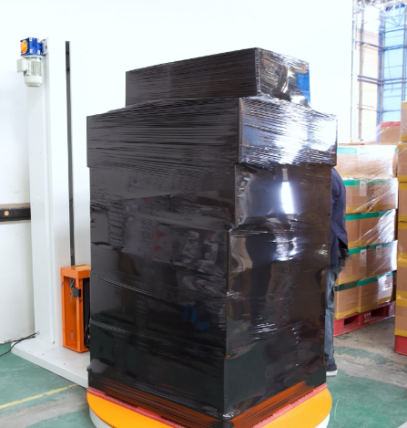 | 